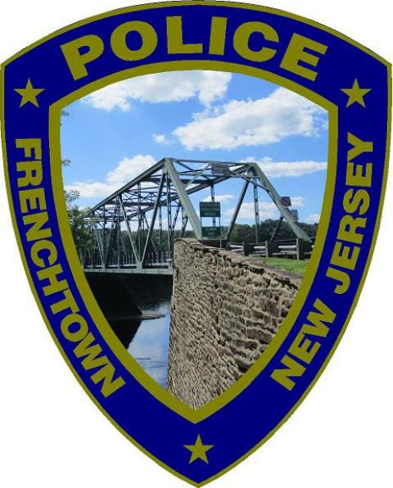
Frenchtown Borough Police Department
27 Second Street
Frenchtown, NJ 08825
Phone No: 908-996-4820 Fax No: 908-996-7134

Applying for a Permit to Carry a Handgun

Frenchtown Borough Police will only issue permits to carry to full-time borough residents. Applicants that are not full-time residents may apply with the closest New Jersey State Police barracks.

- You must apply in person with an appointment. *DO NOT JUST SHOW UP*
- You can make an appointment by emailing secretary@frenchtownpolice.com or calling 908-996-4820

Please provide the following at the time of your appointment:

- Driver’s License and Birth Certificate; or
Driver’s License and Passport; or
Driver’s License and Naturalization Paperwork/Green Card.

- A second form of address verification. Proof of residency via rental agreement, mortgage statement, tax bill, utility bill, or notarized letter from the homeowner.

- One (1) State of New Jersey Applications for Permit to Carry a Handgun, form SP642. Must be double sided and notarized.

- Two (2) color passport size photographs. DO NOT attach to documents.

- Consent for Mental Health Search, form SP066.
DO NOT SIGN OR WITNESS THIS FORM PRIOR TO YOUR APPOINTMENT WITH THE POLICE DEPARTMENT. THIS WILL BE DONE DURING YOUR APPOINTMENT WITH AN OFFICER.

- A written proof of ownership and qualification with the handgun(s) you intend on carrying.

  - Proof of ownership can be a purchase receipt or purchase permit or a notarized letter of ownership listing make, model, and serial number of handgun(s).

  - Written qualification must be within six (6) months of application and include Instructors Name and Certification, make, model, caliber and serial number of handgun(s) you intend to carry.

Applicant must ensure that the instructor has been certified by either
the NRA or PTC only.

- Money order in the amount of $50.00 made payable to: “Treasurer, State of New Jersey.”

- Check or money order in the amount of $150.00 made payable to: “Frenchtown Borough Police Department.”

Originals and copies of ALL documents must be provided at time of appointment. Copies will not be made by the Police Department.

ALL APPLICANTS (INITIAL AND RENEWAL) FOR PERMIT TO CARRY A HANDGUN MUST BE FINGERPRINTED. DO NOT GET FINGERPRINTED UNTIL AFTER YOUR APPOINMENT WITH THE POLICE DEPARTMENT.

To schedule a fingerprint appointment visit:

www.Identogo.com(http://www.Identogo.com)
Service Code: 2F164B – Firearms Licensing
Frenchtown ORI: NJ0101100

A NEW JERSEY PERMIT TO CARRY IS VALID FOR TWO (2) YEARS FROM THE TIME OF APPROVAL.

